At Carinya, quality is not a compliance obligation — it is how we work. This statement sets out our commitment to delivering services that are safe, respectful, and genuinely responsive to the people we support.
Every principle below guides how we make decisions, develop our people, and continuously improve what we do.
Person-Centred Practice
We recognise that every person we support is unique, with their own goals, preferences, and way of seeing the world. Our services are shaped around the individual — not the other way around. People we support have a genuine voice in their care and support planning, and we work alongside them, their families, and their carers to make that real.
Client Experience and Satisfaction
We are committed to services that meet and exceed the expectations of Clients, families, and carers. We actively seek feedback, take it seriously, and use it to drive improvements. When things go wrong, we respond with honesty and care — investigating complaints thoroughly and working toward the best possible outcome for the person involved. We also recognise our accountability to a broader stakeholder community — including the NDIS Quality and Safeguards Commission, funders, alliance partners, and the sector more broadly — and engage openly and transparently with each.
Safe and Capable Workforce
Our staff are central to everything we do. We invest in their training, supervision, and professional development so they have the skills and confidence to provide high-quality support. We are equally committed to their wellbeing — because a workforce that feels valued and supported delivers better outcomes for Clients. This extends to the physical and psychological safety of our workplaces. We meet our obligations under occupational health and safety legislation and maintain safe, accessible environments for both staff and the people we support — including those with complex support needs.
Compliance and Ethical Practice
We meet our obligations under all relevant state and federal legislation and standards, including the NDIS Practice Standards and Code of Conduct. Compliance is our baseline — our aim is to go further, embedding ethical practice and integrity into every aspect of how we operate.
Continuous Improvement
We are committed to getting better. We regularly review our services, systems, and practices — drawing on feedback from Clients, families, staff, and other stakeholders. We look for opportunities to innovate and improve, and we treat problems as prompts to learn rather than issues to manage.

Sustainable and Responsible Stewardship
We manage our resources carefully so that we can continue to provide high-quality services over the long term. Good stewardship means making sound decisions about how we invest our time, funding, and capability — ensuring the organisation remains strong and able to meet the needs of the people we support.
Shared Accountability
Quality is everyone's responsibility. Every member of our team — regardless of their role — contributes to the standard of our services. We hold ourselves to high ethical standards and foster a culture where accountability is understood, welcomed, and modelled from leadership down.
Risk Awareness and Proactive Management
We actively identify and assess risks that may affect the quality and safety of our services. Risk management is embedded in how we plan, make decisions, and review our work — not treated as a separate or occasional exercise. We use what we learn from incidents, audits, and feedback to strengthen our systems and protect the people we support, and we aim to address issues before they arise wherever possible.
Leadership and Governance Oversight
Quality at Carinya is actively governed, not just assumed. The Board of Directors and Senior Leadership Team take direct accountability for the effectiveness of our Quality Management System, ensuring it is adequately resourced, regularly reviewed, and continuously improved. The Quality and Client Experience Manager coordinates and reports on QMS performance, and quality is a standing item at management level. This governance structure ensures our commitment to quality is embedded in decision-making at every level of the organisation.

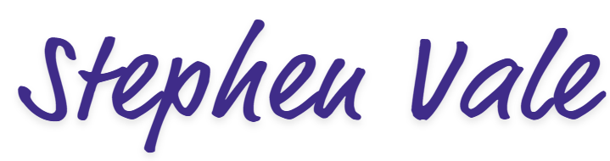
Chief Executive Officer
Date: Friday, 8 May 2026

